New Patient Intake Form

Name: Date of Birth:

Address: Email Address:

Contact number: Occupation:

Relationship Status: Hobbies:

Children: Pets:

What are your goals for the treatment session?

What are you overall goals for health:

Physical:

Mental:

Emotional:

List your current health concerns including the approximate date of onset:

How have these concerns been influencing your daily life and activities?

List previous and ongoing treatments and/or diagnostic testing:

List any medications or supplements that you are currently taking:

What is your typical diet like?

Describe your current exercise or movement routine including how often you exercise or move your body:

Describe your sleep. What time to you go to sleep? How many hours of sleep do you get per night? Do you have trouble falling asleep? Do you wake up rested? Do you wake up during the night, what time?

Describe your elimination pattern. Do you have regular bowel movements (2-3 times per day)? Color and number from the chart?

If you have any pain in your body, please indicate the location by drawing on the diagram, and give that pain a grade on a scale of 1 – 10. (1 = awareness, 10 = extreme)

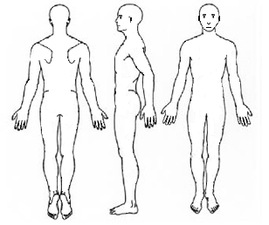

Please rate the following on a scale of 1 – 10 (1 = poor, 10 = excellent)

Quality of Sleep:

Energy Level:

Joy in life:

Stress Level:

Please outline the nature of any stress that you may have in your life:

What types of activities would you like to do more of once this is no longer a concern?

When do you feel at your best physically, mentally, emotionally and/or spiritually?

Can you remember a time in your life when you would have described your state of health as a 10? If so, what words would you use to describe what that felt like?

If you could have one goal that you would like to focus on achieving once your health is restored, what would that goal be?

I _______________________________________________ (print name) understand that the BodyTalk session provided by Yekaterina Sheremetyev, Certified BodyTalk Practitioner is intended to enhance relaxation, increase communication within the areas of the body, and to educate me to possible energetic or emotional blocks that may create pain and disease. BodyTalk is non-invasive, safe, and objective. It utilizes the body’s own innate intelligence to re-establish communication within itself. I understand that BodyTalk is not a substitute for medical treatment or medications. I am aware that the BodyTalk Practitioner does not diagnose illness or disease nor does the Practitioner prescribe medications.

Client Signature: Date: